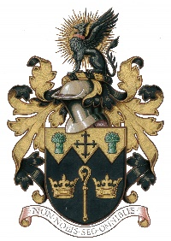
NORTH WALSHAM TOWN COUNCIL

Allotment/Temporary Garden Plots Application Form

North Walsham Sites:-
Bacton Road Cemetery x10 Adjacent to War Memorial Park, Yarmouth Rd x6

Surname:-
First Names:-
Address:-
Post Code:-
Phone No:- Email:-

Any comments you wish to make to support your application

Signed:- Dated:-
The NWTC General Privacy Statement explains how we use your personal data, store it securely and how you can exercise your rights. All data will be destroyed in line with our Retention & Disposal Policy
Please return form to – Office 4, Cedar House, 3 New Road, North Walsham, NR28 9DE
or email to info@nwtc.org.uk

