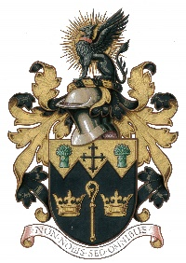
NORTH WALSHAM TOWN COUNCIL

Street Collection
Full Name of Applicant Organiser
Full Address of Applicant Organiser
(Home Address)
Daytime telephone number
Name of Charity or fund to benefit from the Street Collection (Please state name of branch if applicable)
Main office address of the above
Charity/Organisation
Registered Charity Number
Objectives of the Charity /Organisation

Between what hours do you propose to make the above collection(s) (Permits are normally granted between the hours of 9am and 5pm)
Approximately how many persons will be authorised to act as collectors?
Have any steps been taken to ensure the suitability and integrity of the collectors?
Has the applicant, or to the knowledge of the applicant or anyone associated with the promotion of the collection, been convicted of any offence involving dishonesty, fraud, indecency, or any offences involving the conduct of collections? Or has the applicant or anyone associated with the promotion of the collection been refused or had a permit revoked? If yes, please give details. | NO / YES  Details:
I hereby confirm that:
a) the information given on this form is true and accurate and I wish to apply for a licence authorising me to carry out a street collection, and
b) a statement of return showing the amount received and the expenses incurred will be forwarded to the Council within one month after the date of each collection and also the date and place of the collection and amount received shall be published in a local newspaper.

Signed: Dated:

Application for Street Collection Permit

IMPORTANT NOTE
Under the EU Services Directive there is no restriction as to how many charities can collect in a town/parish on any given day.

