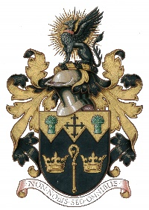
NORTH WALSHAM TOWN COUNCIL

18 Kings Arms Street, North Walsham NR28 9JX Tel: 01692 404114

Application for Erection of Memorial
Made by (Stonemason): Date:

Re: deceased

Application is made for permission to: (please circle and provide sketch/wording on rear of document)
a) Erect a Headstone £127 Double rates are charged for Out of Area
b) Fixed Vase / Tablet £81 (Non NR28 postcode)
c) Desktop / Book Memorial £108
e) Provide an Additional Inscription £62
Cheques payable to : North Walsham Town Council Bac’s: Account No: 82546819 Sort Code: 60-15-54
Material: Colour:
Height: Width: Depth: Length:
Removal Date: Installation Date:

Application made by:
On behalf of: (if applicable)
Signed: Date:
Address:

For Office Use:
Owner of Exclusive Rights:
Name: Number:
Position of Grave/Plot:
Authorised on behalf of NWTC:
Approval Date:
Our General Privacy Statement explains how we use your personal data, keep it stored securely and how you can exercise your rights. All data will be destroyed securely in line with our Retention & Disposal Policy

Email: info@nwtc.org.uk Website: www.nwtc.org.uk

